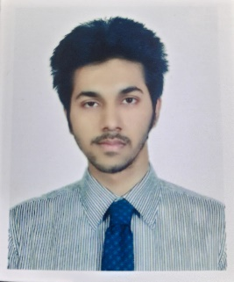

**SK MD ABUZAR GIFARI** House: 1, Road: 8, Block: C,Mirpur 13, Dhaka- 1216**e-mail:** abuzargifari098@gmail.com**Tel:** +8801783753653

**ABOUT ME:**

Date of birth: 18th September,2000Nationality: Bangladeshi Marital status: UnmarriedReligion: IslamSex: MaleBlood Group: A+

**EXPERIENCES:**

1. **Web Designer**

People n tech, Bangladesh.The main work was mine to create creative project for the company.

**EDUCATION:**

1. **2020-Ongoing**Bachelor of Business AdministrationStudy in software engineering

Daffodil International University, Dhaka.

1. **2017-2019**Higher Secondary School CertificateShaheed Police Smrity CollegeGPA: 4.08 out of 5 from Science.
2. **2015-2017**Secondary School CertificateAdamzee Cantonment public schoolGPA: 5 out of 5 from Science.

**INTERNSHIP, TRAINING AND WORKSHOP:**

1. Participated and successfully completed 6-month Advanced Web Design course from **People n tech in 2020**.
2. Participated in **UDMEY's** Web Development Boot camp and received a certificate in 2020.
3. Already done many courses on web development from **UDEMY** course.
4. Already completed many **projects on my own**, including **e-commerce Site Design, PSD to HTML, Bootstrap Responsive Site Design.**

**LANGUAGE AND PROFESSIONAL SKILLS**

1. Mother tongue: Bengali, Fluent in Bengali and full working knowledge in English.
2. Ability to make negotiation with clients.
3. Expert in meeting up client requirements.
4. Seeking knowledge related to my work field.
5. Experience to make projects as a team.

**COMPUTER AND SOFTWARE SKILLS**

1. Sound knowledge on operating Microsoft word, PowerPoint, excel.

**INTERESTS**

1. Listening to Music
2. Watching movies
3. Travelling